**Business problem:** create a model that gives us the estimated salary for an employee based on the position.

**Explaining the model**

1. Import the dataset, which is in a csv format.
2. We don’t need to encode categorical data because we already have one column in our dataset that represents the position – we subset our data set, just to have one dependent variable and one independent variable.
3. Since it’s a dataset with only 10 rows, there’s not enough data to create a training and teste sets, therefore we will not split.
4. After installing the package e1071, we create our regressor. The first argument of the svm function is the formula, in which we place our dependent variable first and the other next. After that, we chose our dataset and then the type, which in this case, since it’s a regression model, we choose the eps-regression.
5. Here is our regressor, with 6 support vectors.

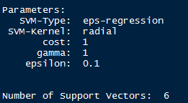

1. It’s now time to test our model.

**Analyzing the results**

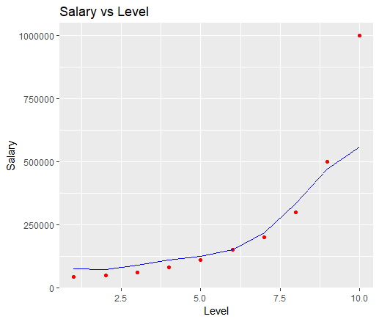

As we can see, our model doesn’t fit as well as the polynomial.

**Prediction**

Imagining a person has 2 years of experience as a Region Manager (level 6) and needs 2 more to jump to a Partner (7), we can consider it to be a 6.5 regarding the Level. Therefore, our model predicts a salary of $177.871, against the $174.878 of the polynomial.